//Code

To find the largest number using pointers

#include<stdio.h>

int main()

{int a[10],n,i,max; //declarations

int \*p;

printf("Enter how many elements "); //accepting size

scanf("%d",&n);

printf("\n\nEnter %d elements of array ",n); //accepting elements

for(i=0;i<n;i++)

{

scanf("%d",&a[i]);

}

max=a[0]; //logic to find largest element using pointer

p=a;

for(i=0;i<n;i++)

{

if(\*p>max)

{

max=\*p;

}

p++;

}

printf("\n\nElements are \n"); //displaying elements

for(i=0;i<n;i++)

{

printf("%d ",a[i]);

}

printf("\n\nLargest element is %d",max); //displaying largest element

return(0);

}

Output:

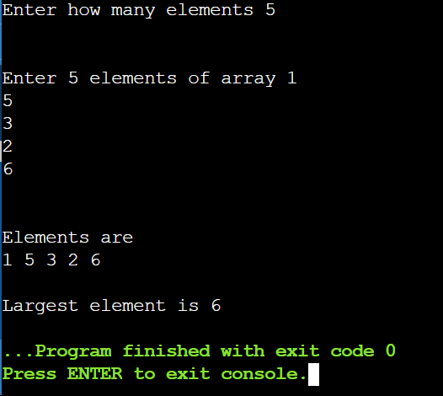

Conclusion: C program to find maximum element in an array using pointer was implemented

successfully.